**Internet & HTTP**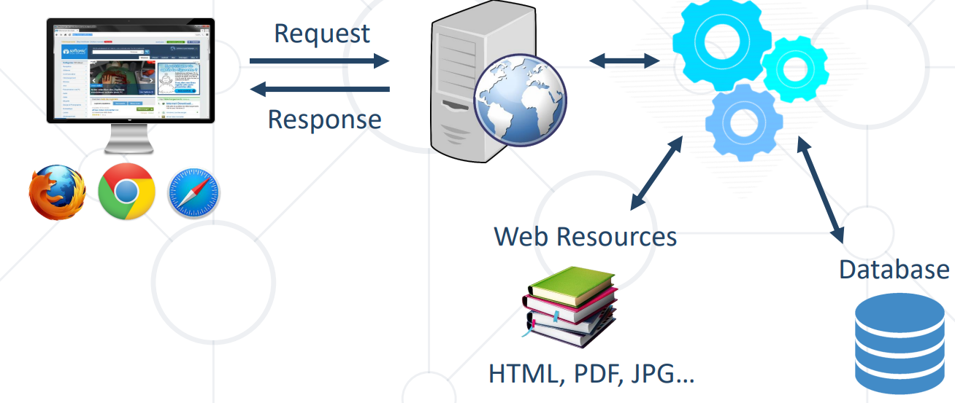

**Server** – machine that provide services to other machines  
**Client** – end point devices that are used to connect to those machines

**Network Protocol** – set of rules and standards that allow communication between network devices  
**Protocol** – collection of rules & standards

**HTTP** – hypertext transfer protocol  
**Packets** – data (message, file or stream) is sent over computer networks broken down in packets  
  
**TCP protocol** - Transmission Control Protocol – used to establish a connection between devices, ensuring that data is transmitted reliably, in the correct order, and without errors  
**IP** – Internet Protocol – each device in the network has a unique IP address (at the edge of the network)  
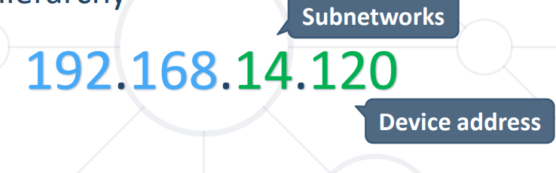

**DNS** – Domain Name Server - human way to access IP addresses for devices and websites  
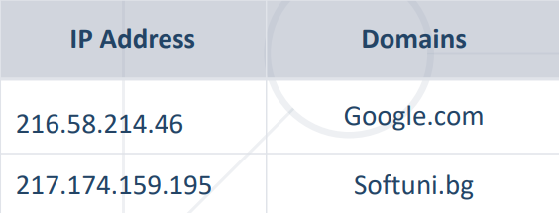

**HTTP**  
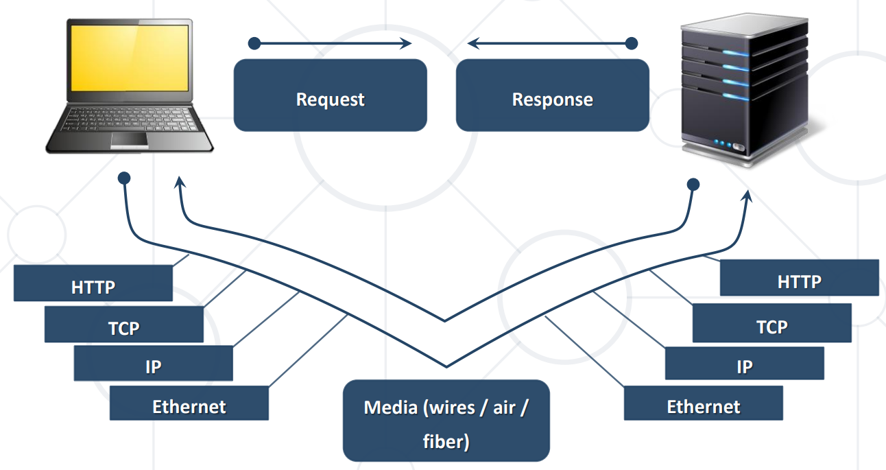

HTTP request methods:

POST - Create / store a resource   
GET - Read / retrieve a resource   
PUT - Update / modify a resource   
DELETE - Delete / remove a resource  
  
HTTP Request convention:  
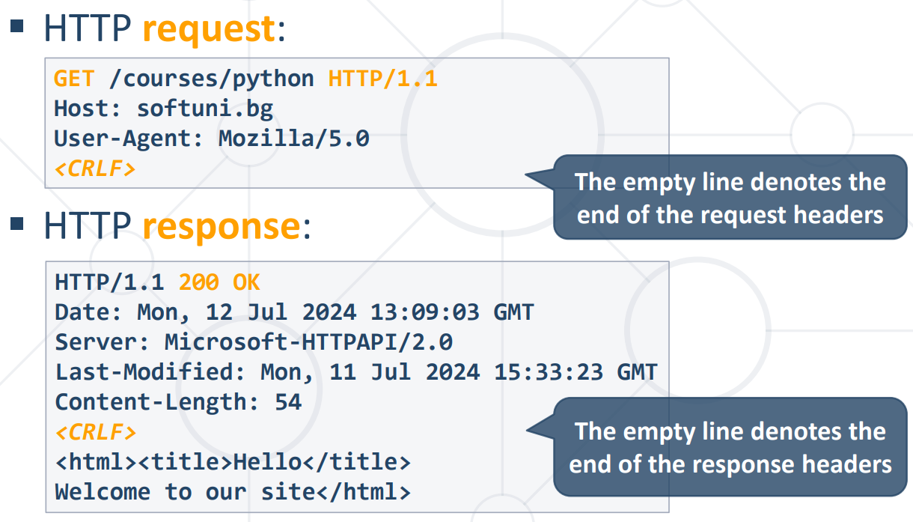

HTTP request:  
HTTP Request Line  
 - method (GET/POST/PUT/DELETE)  
 - resource URL  
 - Protocol version  
HTTP request headers  
empty line <CRLF>  
request body (only for POST/PUT)  
  
HTTP response:  
HTTP Response LIne  
- protocol version  
- status code  
- status text  
HTTP response headers  
empty line <CRLF>  
response body

HTTP 1 vs HTTP 2  
- fast and optimized  
- backwards compatible (bi-directional communication)  
  
**URL** – Uniform Resource Locator  
- specifies a web resource location on a network and the mechanism for retrieving it  
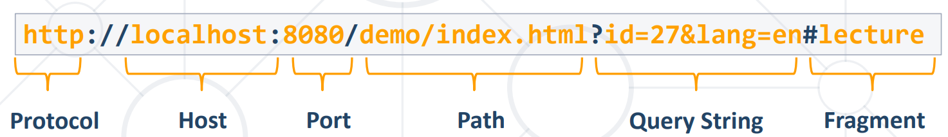  
  
URL encoding:  
- Safe URL characters: [0-9a-zA-Z], $, -, _, . , +, * , ' , (, ), ,, !  
- All other characters are escaped by %[character hex code]  
- Space is encoded as "+" or "%20"

**MIME – Multi-Purpose Internet Mail Extensions**- internet standard for encoding resources/file types (text/json/jpeg)  
- specified in the header section of the HTTP request  
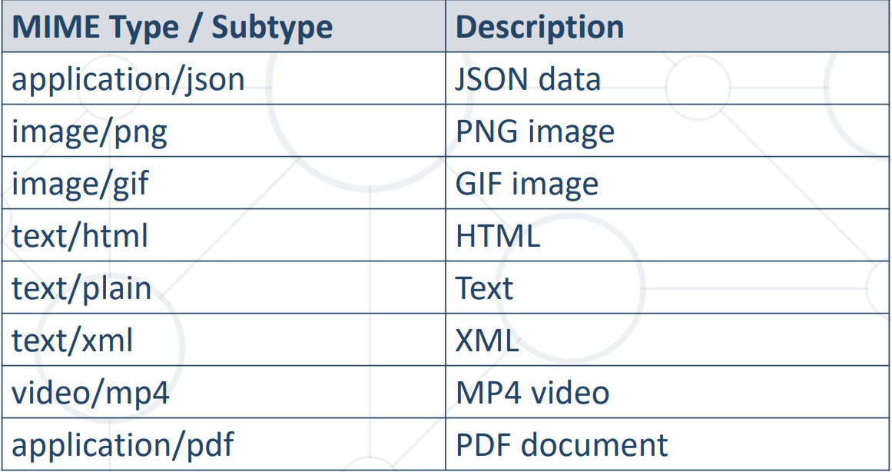  
  
HTTP request Status codes  
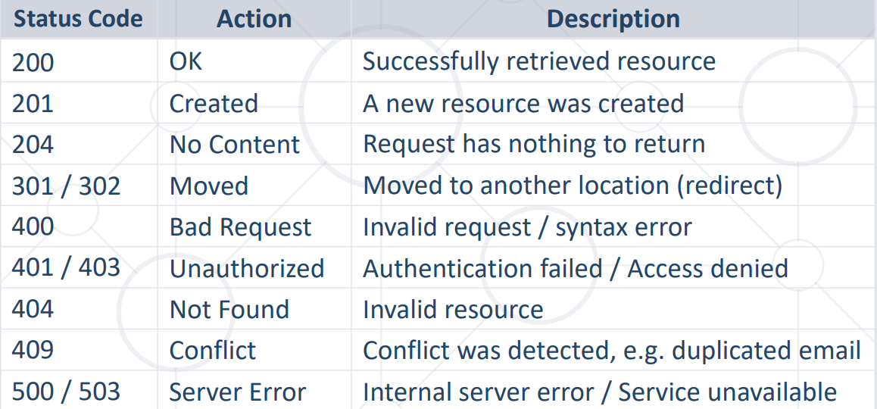

**Django Introduction**

Framework – foundational structure or set of tools  
- provides reusable components  
- includes libraries, templates, predefined patterns

**Django**  
High-level Python Web Framework (provides speed, security, scalability, Open-source nature)  
Follows MVT design pattern  
  
**Model** – defines the structure and behavior of data  
**View** – **callable** that takes an HTTP request and returns an HTTP response  
 - contains application business logic)  
**Template** – the presentation (front-end layer)  
 - text file, written in special syntax that allows a dynamic generation of HTML  
 - provides a convenient way to generate dynamic pages using DTL (Django Template Language)  
**DTL** – Django Template Language  
  
**Django apps**Each **App** is **separata package** part of the **project** with a **single responsibility**

**Creating a project in Django:**STEP 1:Create a project  
STEP 2: Create an app  
STEP 3: Add the app to INSTALLED_APPS  
STEP 4: Replace the DB settings with postgres DB settings  
STEP 5: Enter credentials  
STEP 6: Install psycopg2  
STEP 7: Create the DB  
STEP 8: python manage.py migrate

**Django App** – web application that does smth (small task) (can be used in multiple projects)  
**Django Project** – collection of configurations and apps for a website (can contain multiple apps)  
 **Project Structure:**__init__.py – defines the directory as Python package  
settings.py – configuration file for the project  
urls.py – table of content, contain all urls and paths to resources  
 - configure which function or logic should be executed when reaching a given url  
manage.py – tool for executing commands  
  
**App Structure:**  
admin.py – admin page  
apps.py – config of the current app/module  
models.py – the models of the app  
test.py – views of the app  
views.py – views/business logic of the app  
migrations.py - command-line utility for propagating changes in models  
  
**render** function – tells the DTL to replace specified context in a specified template and return as HTTP response  
**context** – dictionary, keys refer to variables and then can be accessed in the HTML template  
HTML template syntax:  
  
{% %} – template tag - contains Python logic (if/for)  
{{ }} – variables  
| - filters – {{ variable|length }}  
  
MPA – multi-page application (each time we need new info we reload the page)  
SPA – single-page application (requests are sent to server, the server returns JSON and via JS the front page is updated)  
  
**Django URLs**

**URL** – Uniform Resource Locator  
- path on which we load a certain view  
- specifies a web resource location on a network and the mechanism for retrieving it  


Static path -   
Dynamic path  
  


Path converters:  


**str** - matches any non-empty **string, excluding "/"  
int** - matches zero or any **positive integer  
slug** - matches **any slug string consisting of ASCII letters, numbers, hyphens, and underscores**  
**path** - matches any **non-empty string, including "/"**   
**uuid** - matches a formatted **UUID**RegEx in URLs  
  
- for more flexible and complex URL pattern matching

**include()  
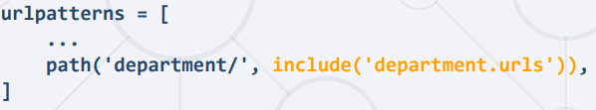**- removes redundancy from URL configuration modules, especially when a single pattern prefix is used repeatedly  
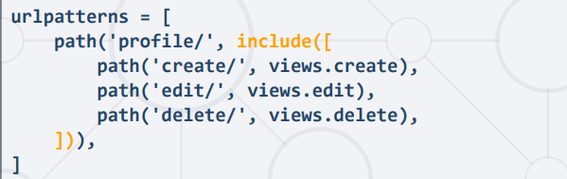

**Django Views**  
- contains the logic necessary to produce the desired outcome when a specific URL is accessed  
  
  
  
Each view receives:  
- **HttpRequest** **object** as its first argument  
- *args - matches from no named groups in the URL pattern   
- **kwargs - matches from named parts in the URL pattern  
Each view returns:  
- **HttpResponse object**

**HttpRequest:**  
- Incoming HTTP request from a client (usually a web browser)  
- Contains info about the request (headers, method (GET, POST, etc.), user session, and any data submitted in the request)  
- Passed as the first argument to a view function  
  
**HttpResponse:**  
- HTTP response that a view sends back to the client in response to a request  
- Contains the content that will be sent in the response along with any relevant headers (e.g., content type, status code)  
- Views are expected to return an HttpResponse object which can include HTML content, JSON data, or any other type of response content

**render()** – combines HTML template with a context dictionary  
Simplifies the process of rendering dynamic content

required arguments:  
 - request (the HttpRequest object)  
 - template_name – the name of the HTML template  
Optional:  
 - context - dictionary containing values that are added to the template context  
 - status (200, 404, etc.)  
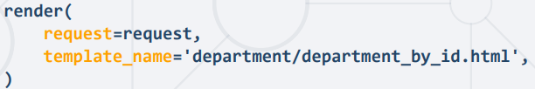

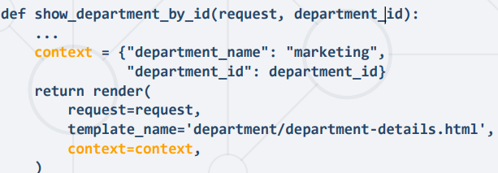  
  
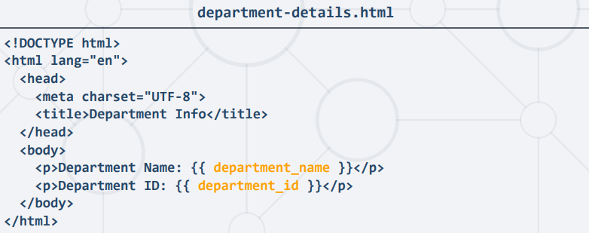  
  
get_object_or_404()  
get_list_or_404()  
  
**redirect()** - Is used to redirect the user to the appropriate URL  
- By passing a hardcoded URL to redirect to  
  
- By passing the name of a view along with optional positional or keyword arguments  
  
- Returns HTTP status code of 302  
  
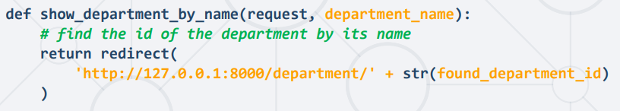  
  
**resolve_url()** – finds the url that matches the view

**reverse()** - generate a URL for a specific view based on its name and any arguments  
receives the name of the view + additional arguments (*args, **kwargs) and returns URL path  
  
Communicating Errors:

raise Http404()  
return HttpResponseNotFound()  
return HttpResponse(status=404)

**Templates in Django**- text document (HTML file, txt, xml)  
- utilize DTL (Django Template Language) to generate content dynamically  
- render the info from the views  
- Django provides a standard API for loading rendering templates  
  
Static vs Dynamic HTML sites  
  
DTL supports the below key elements:  
 - Variables  
 - Filters  
 - Tags  
 - Comments  
  
**DTL Variables**- access view context variables in HTML tempalte- referred to in the HTML file by {{ }}  
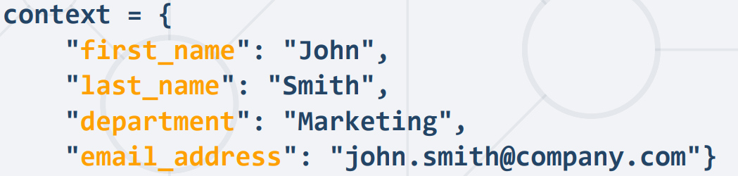  
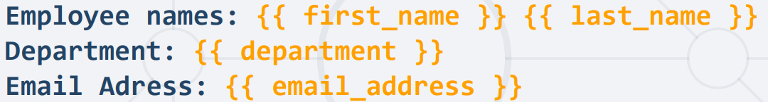  
- variable properties and methods can be accessed with .  
- functions can be called as well as long as they do not require arguments  
  
**Build-in Filters**- used to modify variables before they are displayed  
- use “I” followed by filter’s name  
{{ variable_name|filter_name}}  
- filters can be chained  
- filters can accept arguments using “:”  
{{ variable_name|filter_name:argument }}

Common in-built filters:  
truncatechars - first N chars  
truncatewords – first N words  
join:", " – join list elements  
default:"nothing" – if variable is false or empty, use the given default value  
date:"D d M Y" – format date to specified format  
floatformat:N - rormats float value to the Nth decimal place  
length - returns the length of the value (string or list)

**Tags**- incorporate custom logic into the rendering process  
- enclosed within {% and %} delimiters  
- accept arguments to further customize their behavior  
- if statements:   
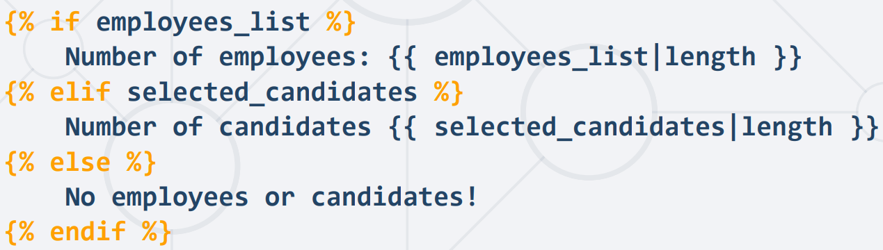  
  
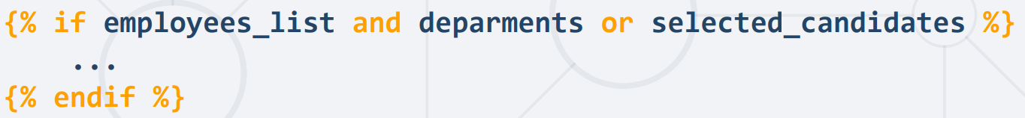  
  
- for cycles  
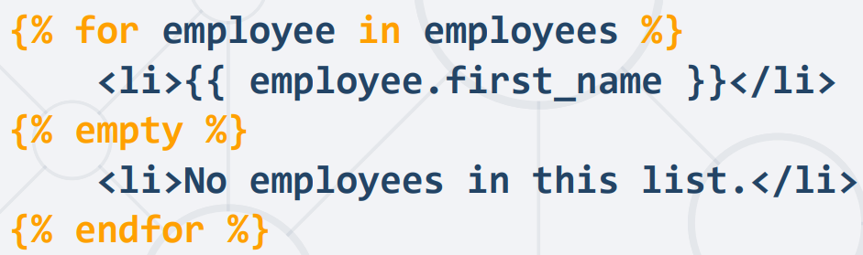

- **URL tag** – can use the name of the path instead of the hardcoded URL  
 - can accept optional parameters

**csrf_token**  
- provides CSRF (Cross-Site Request Forgery) protection  
- placed inside the <form> element in the HTML code  
- CSRF - type of malicious exploit where unauthorized commands are executed on behalf of authenticated users without their consent or knowledge

**Static Files in Django**- JS, CSS  
- Ensure STATIC_URL variable is defined in settings  
  
- Ensure STATICFILES_DIRS variable is defined in settings to indicate the directories where your static files are located  
  
in the path you access the static files by static/ + the staticfiles dierectory  
  
{% load static %} – load the static files into the HTML template  
added at the top of the template  
  
Including a specific CSS file in the HTML template  
- set the link's href attribute to the URL of the CSS file (including the STATIC_URL variable)  
  
  
Including an image in the HTML template  
- set the src attribute of the <img> tag to the URL of the image file (including the STATIC_URL varible)  


**Forms Basics**

**Web form** is an online page that enables users to input data  
- emulate traditional paper documents where users complete fields  
- data is then transmitted to a server for processing  
- encompass various elements:  
 - text boxes  
 - check boxes  
 - select options

- when using GET method all populated elements are then passed as query parameters (in the URL) in a form of dictionary  
  
- when using POST method it is mandatory to have CSRF token and data is send as part of request body  
- In HTML, forms are wrapped within theTop of Form <form> tag  
- work only with GET & POST methods  
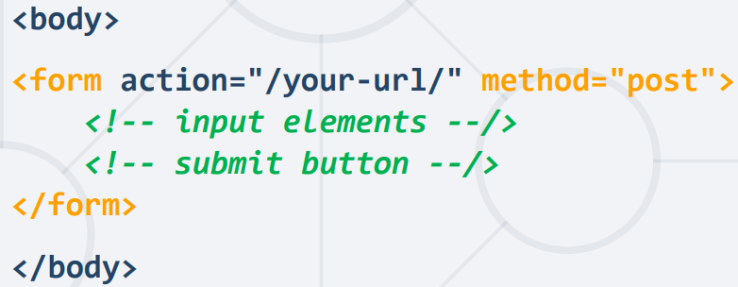

**Django forms**  
- enable creation of forms using Python code  
- support all features of HTML forms  
- simplify and automate the form creation & handling process  
  
Creating forms in Django:  
 - almost identical to creating models  
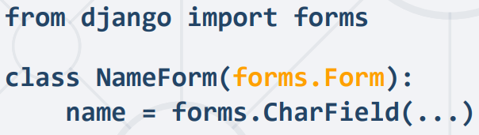  
- Django form class:  
 - defines the **form fields** (type of data the form will collect)  
 - determines the **behavior** and **appearance** of the form  
 - Handles **validation** when the form is submitted

Django form handling:

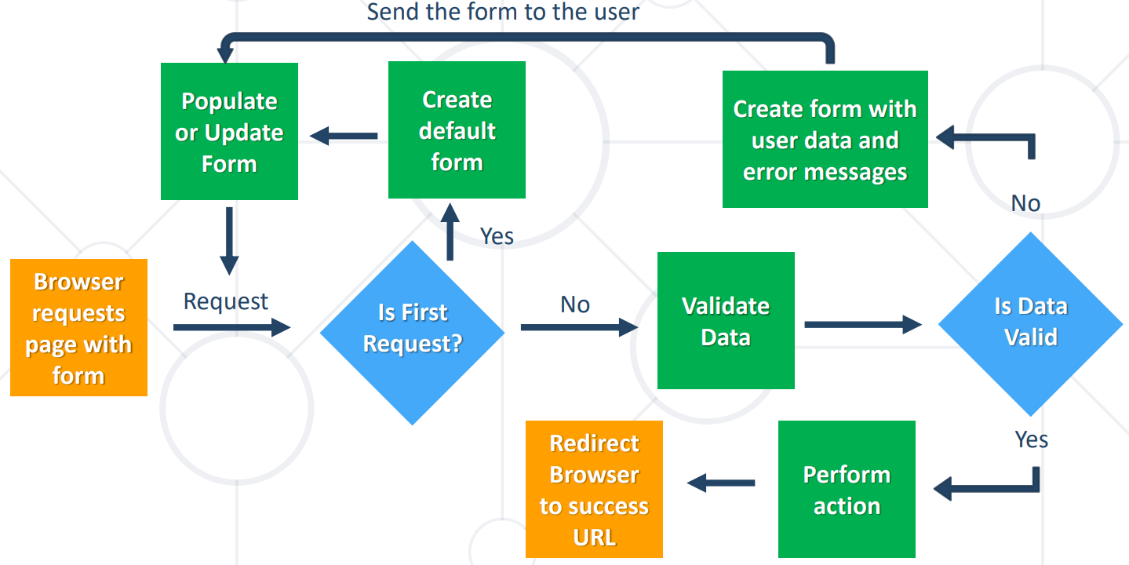

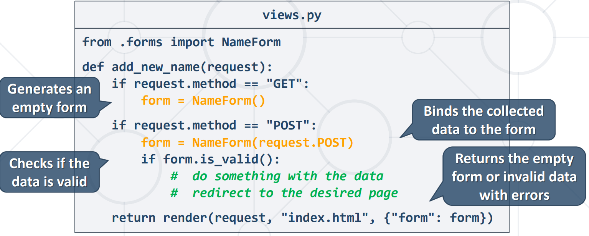

Simplified:

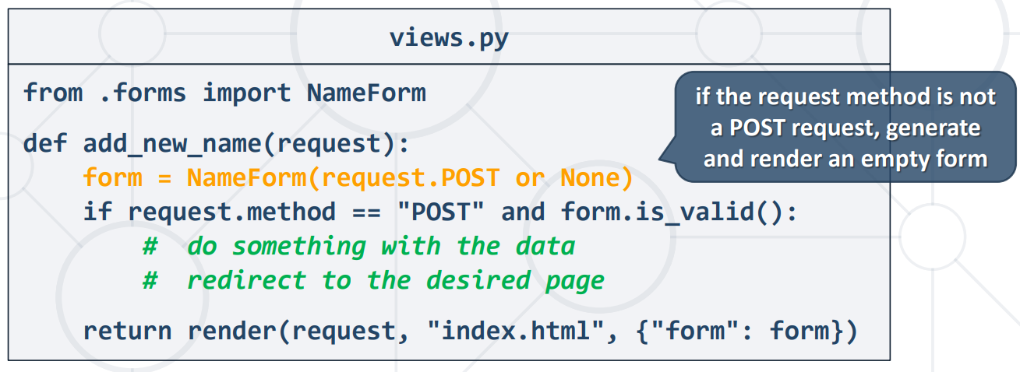

Create a template with the form:  
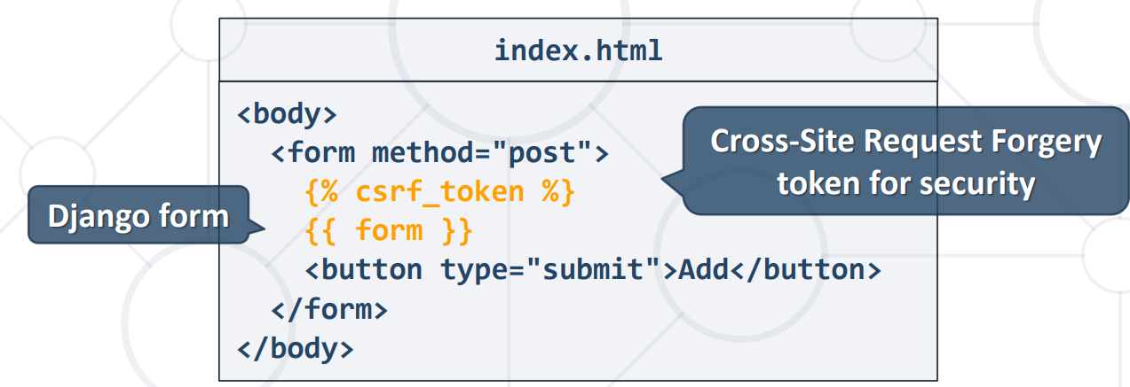

Django form fields:  
- Each field incorporates custom validation logic  
- Fields can take common and field-specific arguments  
- By default, each field requires a value to be entered or raises a ValidationError (can be handled with required attribute)  
  
- Labels apply a "user-friendly" label on the form  
  
- **help_text** attribute is used to display additional instructions/legend for the field  
- **initial** argument lets you specify the initial value  


**Django Widgets:**

- representation of an HTML input element  
 - widgets handle rendering of HTML and extraction of data  
 - Django automatically assigns default widgets based on data type  
 - different widgets can be specified for a field using the widget argument

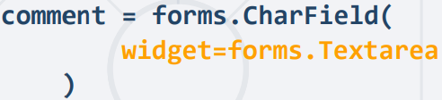

Other built-in widgets:  
 - TextInput (text)  
 - TextArea (multiline textinput)  
 - NumberInput (number)  
 - EmailInput (email)  
 - PasswordInput (password)  
 - URLInput (URL)  
 - DateInput (text)  
 - DateTimeInput (text)

**select list** – default widget for ChoiceField  
widget=forms.Select  
  
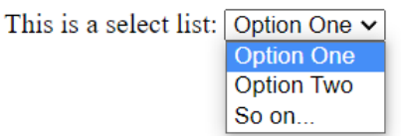  
  
**checkbox** – default widget for BooleanField  
**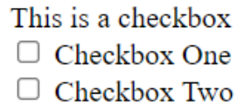  
  
radio button** – similar to Select widgfet  
widget = forms.RadioSelect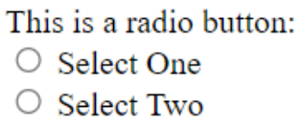  
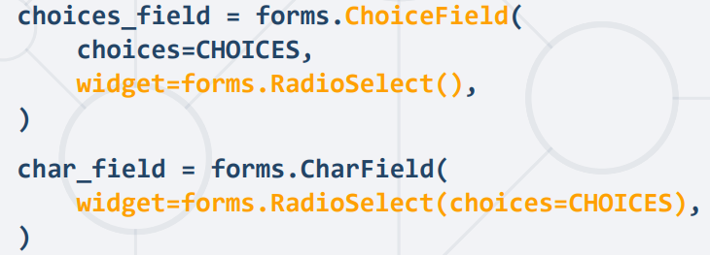

Widget Attributes - specify HTML attributes using Python code  
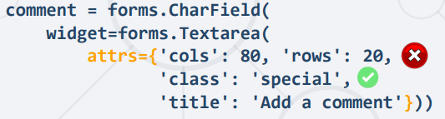  
  
**Django Model Forms:**

- the form mirror the models already specified in the DB  
- automatically generate a form based on specific model  
  
Form vs ModelForm:  
**Form:**   
- Independent from the model and does not directly interact with models   
- search form, contact form, subscription form  
**ModelForm:**- Converts a model into a form  
- directly interacts with models by adding or editing them  
- registration form, newsletter article form, blog post form

Creating a Django Model Form:  
1. Create the form in forms.py  
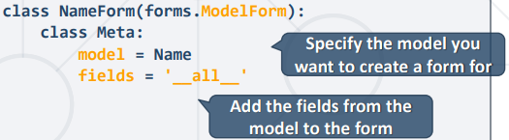

ModelForm Meta class:  
- specify the name of the model  
- can include all fields from the form – fields = “__all__”  
- can include specific fields – fields = [“first_name”, “last_name”]  
- can exclude specific fields – exclude = [“last_name”]

2. Create a view with a corresponding URL path: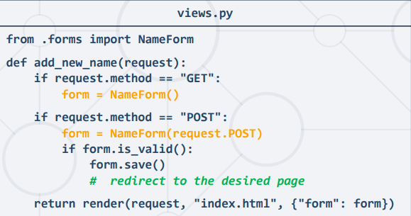

3. Create a template with the form:  
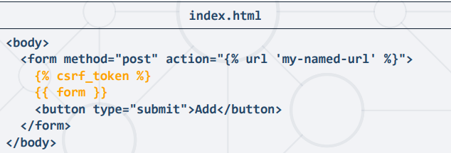

Overriding default ModelForm field widgets:  
default:  
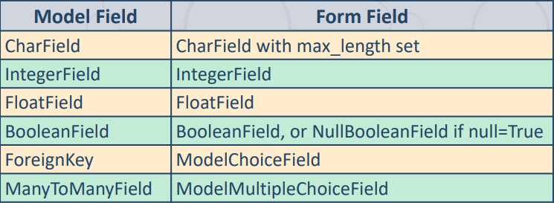

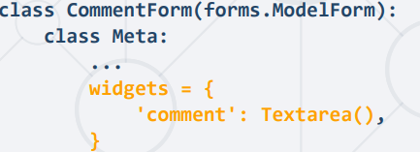

Overriding default ModelForm field labels:  
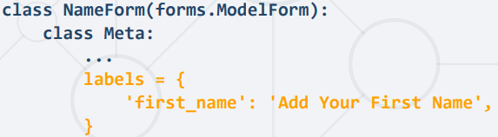

**Template inheritance**

* creation of a foundational base template/skeleton with shared elements and blocks that child templates can customize

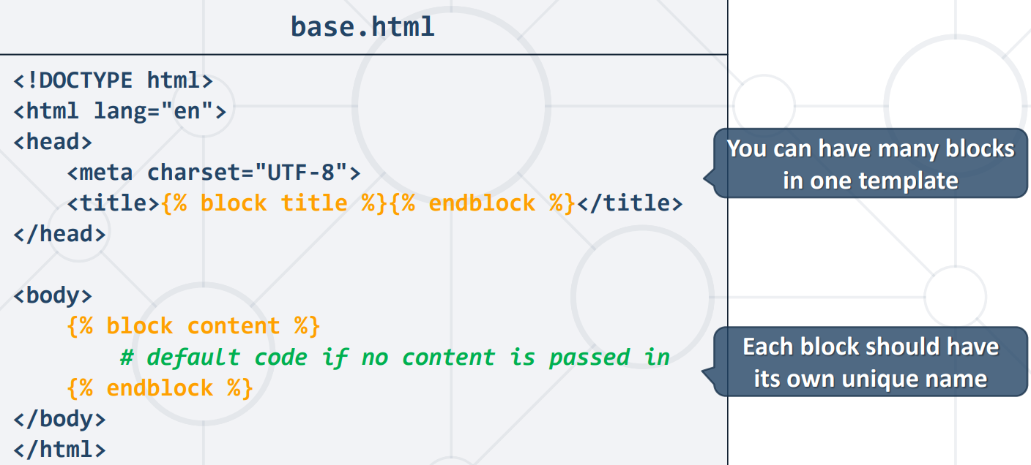

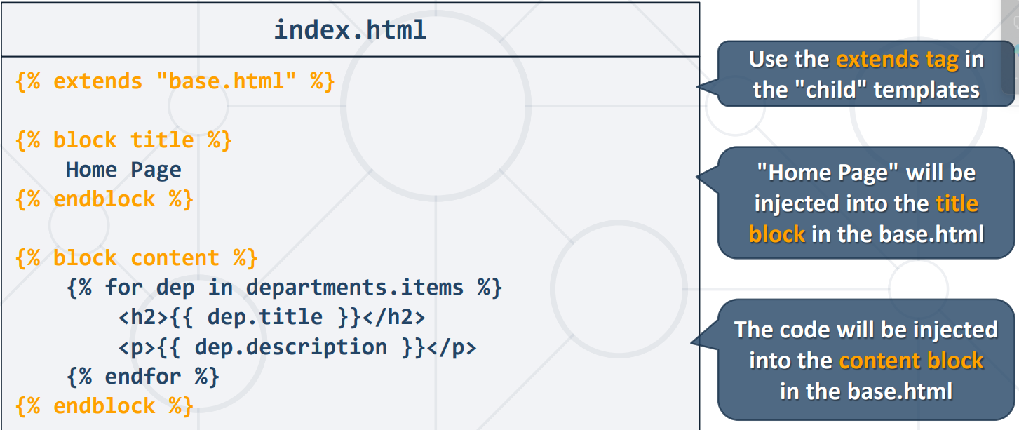

blocked items can still be inherited and extended with {{ block.super }}  
  
  
**Including Template Snippets**

* way to include templates within another HTML template (navigation bars, search bars, etc.)

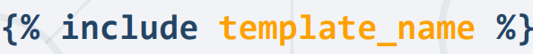  


Django replaces the {% include …%} tag with the HTML we are referring to

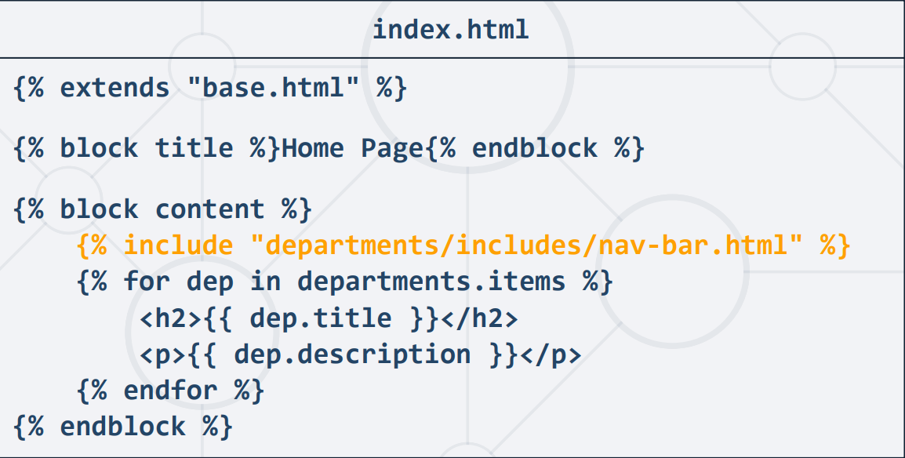

**Include with Context**

* Additional context can be passed to the included template using keyword argument

**Custom Filters**

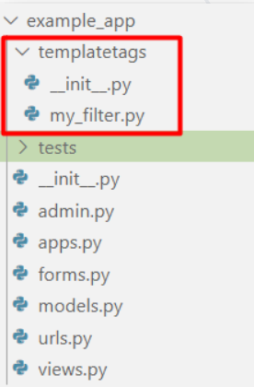 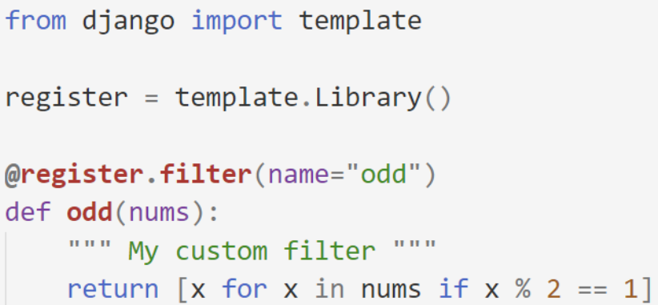  
  
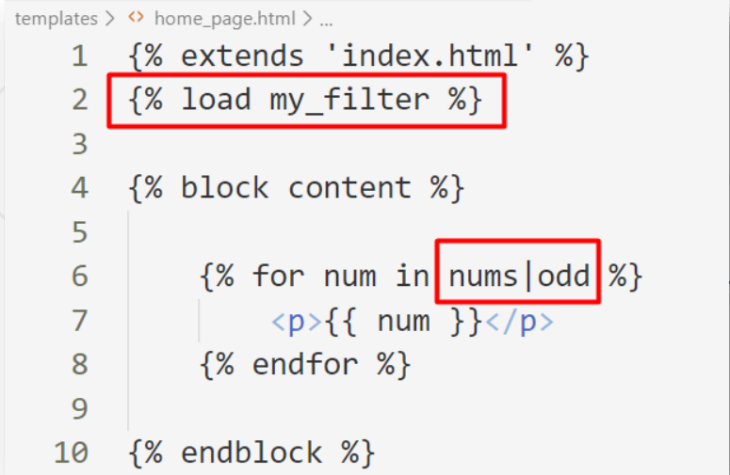

**Custom tags**

simple_tag – returns string  
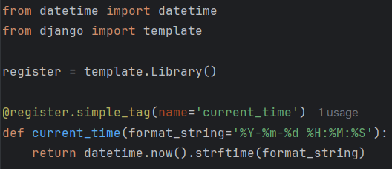

inclusion_tag – returns rendered template (HTML)  
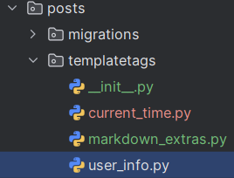 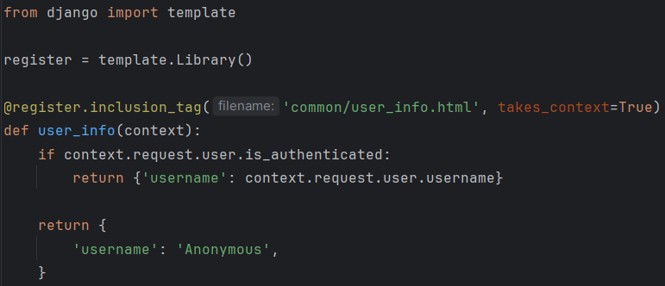

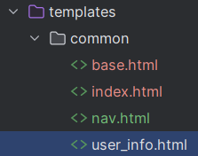 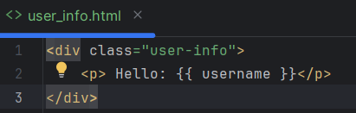

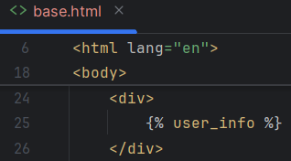

**Bootstrap**

* open-source front-end framework that simplifies the process of designing responsive web pages
* includes a set of pre-designed HTML, CSS, and JavaScript components
* <https://getbootstrap.com/>

**Django Validators**

* callable (function or class) that assesses whether a given value meets specific criteria
* if the value satisfies all criteria it doesn’t return anything
* else raises a ValidationError  
  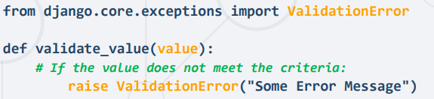
* validators can be in the models or in the forms

**Form Validation:**

* occurs during data cleaning process in Django
* raises ValidationError
* cleaned and normalized data is returned as Python object
* you can use Custom and Built in Django validators  
  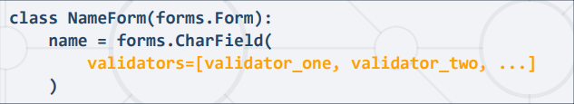

**Model Validation:**

* used most often because they inherit the validators defined in the Models and can further extend in the forms
* validating the model – data adheres to the validation rules in the corresponding Django Model
* validating the form – implement custom validation logic beyond the one defined in the model

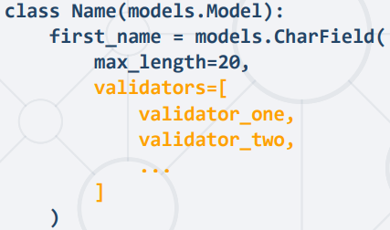

**Error Messages in Forms:**

* error messages from validators can be customized by overriding the default message
* passed in a dictionary with keys and error messages

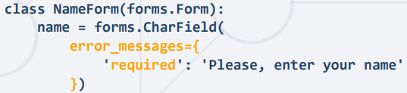

**Error Messages in Models:  
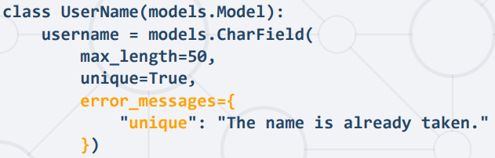**

**Error Messages in ModelForms:  
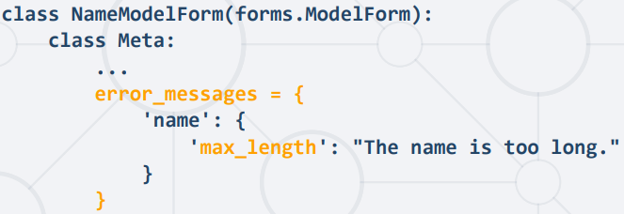**

**Form Class Methods:**

* __init__(self, *args, **kwargs) – used to initialize the form and can be overridden to perform any setups

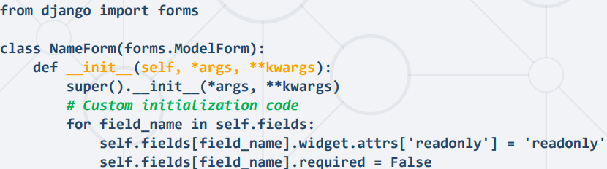

**is_valid(self)** – used to check if form data is valid  
triggers the validation of all fields and returns True if form is valid

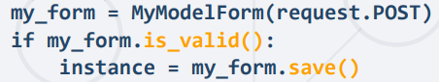

1. **is_valid(self)** checks/calls **self.errors**
2. if **self._errors** is None calls **self.full_clean()** (otherwise returns self._errors)
3. when **self.full_clean()** is called it creates **self.cleaned_data** attribute and calls **self._clean_fields()** and **self._clean_form()**
4. **self._clean_fields** then calls each **clean_fieldname(self)** – implement custom cleaning/validation for a specific field  
   automatically called during form validation

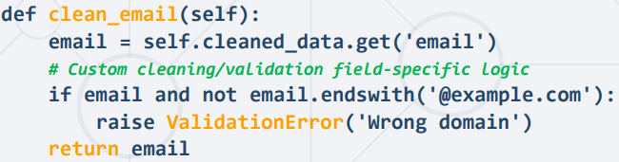

1. then **self**.**full_clean()** calls **self._clean_form()** which calls **clean(self)** – called after all individual fields clean methods  
   used for overall form cleaning/validation

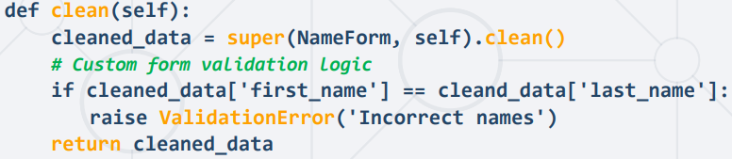

1. save – saves the form to the database (for ModelForms associated with Django models)

**ModelForm Functions/Formsets**

modelform_factory – creates forms from a given model (can be made dynamic based on the context)  
  
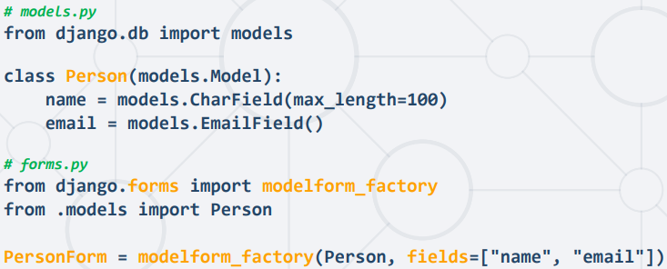

**formset** – collection of forms  
creates n amount of a specified form  
allows to work with multiple forms on the same page

formset_factory accepts the below attribures:  
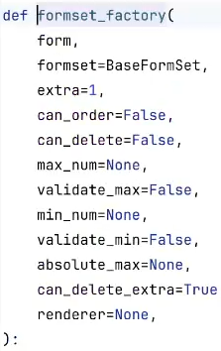

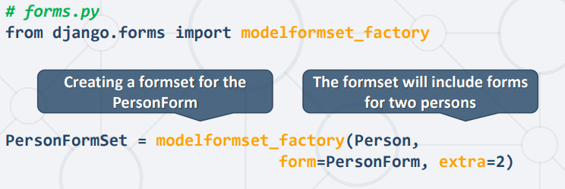

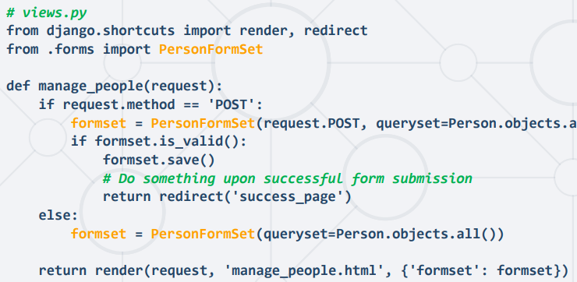

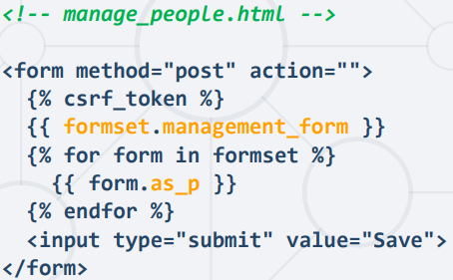

**Styling forms**- forms can be represented in various ways (as a form, as a paragraph, as a list and etc)  
using **as_p, as_div, as_table, as_ul**  
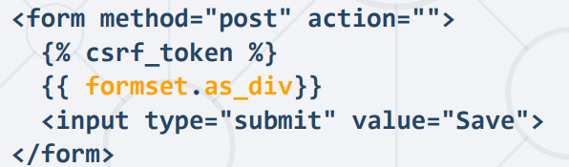

**Crispy Forms**

* library that allows to have styling by default without writing bootstrap classes
* requiring to install **django-crispy-forms** and **crispy-bootstrap4**
* Crispy Forms and Bootstrap4 needs to be added to the installed Apps  
  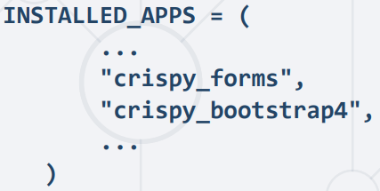
* In the settings.py need to set the default template pack  
  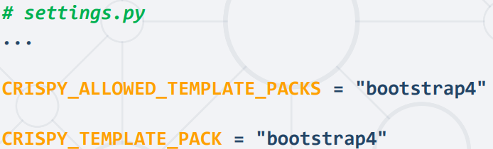
* you can use instance-level helper to customize the form rendering

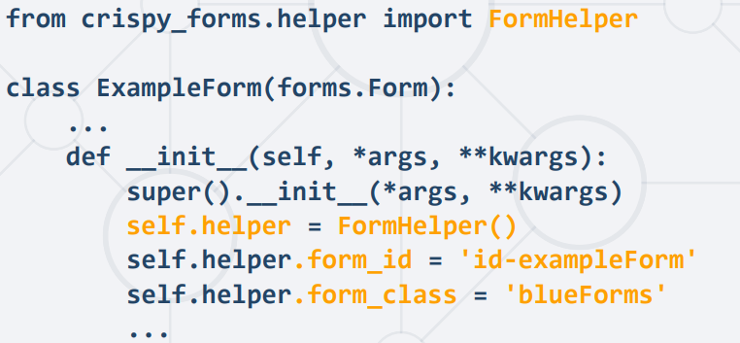  
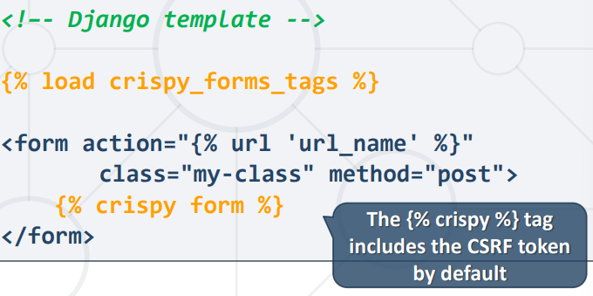

**Media Files**

* static files vs dynamic files
  + static files are saved on the server (file system)
  + dynamic files are save in s3 buckets or other cloudinary
* pictures, music, audio, videos, and documents

1. Install Pillow library – pip install Pillow  
   Pillow is a Library that enhances Python's capabilities for opening, manipulating, and saving a wide range of image file formats  
   Supports PPM, PNG, JPEG, GIF, TIFF, and BMP
2. configuring media folder:  
   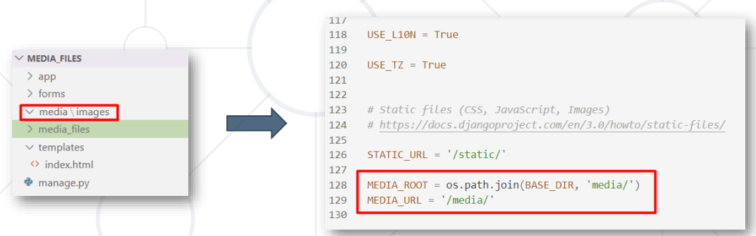
3. register the media url  
   
4. Create an Image Field in the Model  
   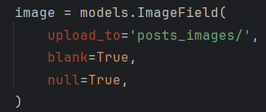
5. update the relevant template and form tag to accept files  
   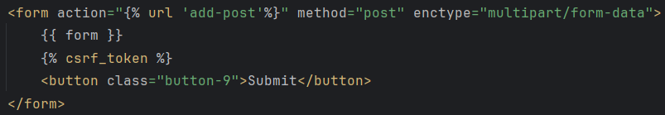
6. Update the relevant form view



1. Displaying the image – update the relevant template html  
   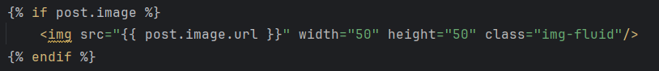

**Class-Based Views**

* views are defined as Python classes instead of functions
* encapsulate the logic of handling HTTP requests and responses
* django provides ready-to-use class-based views for common patterns
* support inheritance, reuse of code an implementation of mixins
* maintain state across different methods

Mixins – specific functionality is encapsulated in separate classes (mixins)

Pros & cons vs function-based views:

|  |  |
| --- | --- |
| Class-Based Views | Function-Based Views |
| + Extensibility  + Reusability and Modularity  + Organization and Structure  + Built-in Views  - Harder to Read  - Implicit Code Flow  - Hidden Code in Parent Classes/Mixins | + Simplicity and Readability  + Direct Mapping to HTTP Methods  + Explicit Code Flow  + More Concise for Simple Cases  - Hard to Extend  - Hard to Reuse  - Handling HTTP Methods via Conditional Branching |

**Base Views**

* foundational or parent views in Django
* used independently or inherited from other views
* starting point but might not cover all the capabilities needed

**View Class**

- foundational master class-based base view in Django  
- all class-based views inherit from this base  
- defines all HTTP methods that the view can handle (get, post, put, patch, delete etc.)  
  
**as_view** method  
- class only method (decorated by a @classonlymethod, cannot be accessed through the instance)  
- iterates over initkwargs, performing validations and prep the view for handling requests

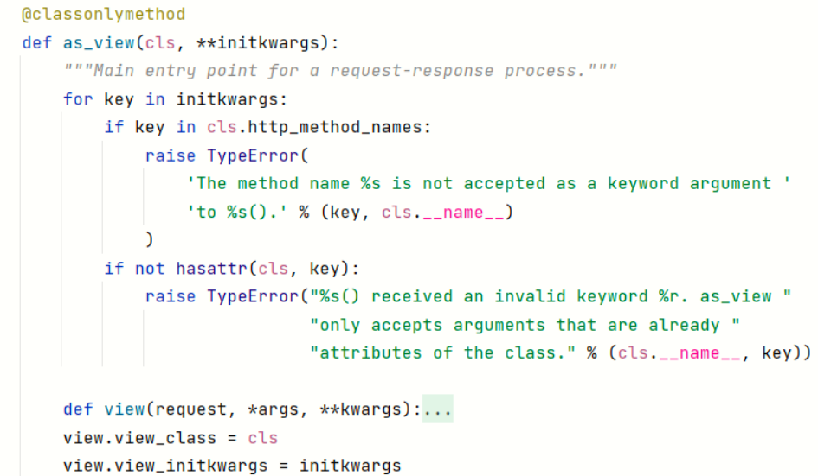

**view** function – called within the as_view method  
- accepts parameters (request, *args, and **kwargs)  
- during execution, attaches the instance of the class to the class attributes using self  
(assigns request to self.request, args to self.args, and kwargs to self.kwargs)  
- executes the dispatch() method **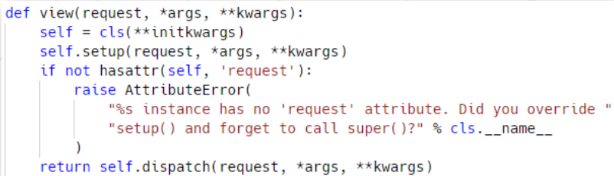  
  
dispatch** method - determining which method to call based on the HTTP method of the incoming request  
- executed by the view function  
- acts as a kind of router for directing the flow of control to the appropriate method  
- can override specific methods (get, post) to customize the behavior  
  
**Request-Response Lifecycle**1. Initialization  
2. as_view() Method  
3. dispatch() Method  
4. Pre-processing (Optional)  
5. HTTP Method-Specific Methods  
6. View Logic Execution  
7. Response Generation  
8. Post-processing (Optional)  
9. Response Sent to Cl

**Generic Views  
  
TemplateView** - render a specified template, enriching the context with parameters captured from the URL  
- inherits methods and attributes from three main classes  
 - TemplateResponseMixin  
 - ContextMixin  
 - View  
  
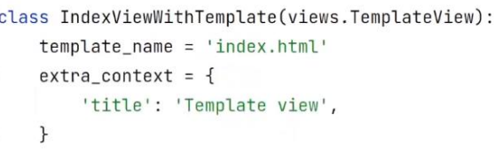  
  
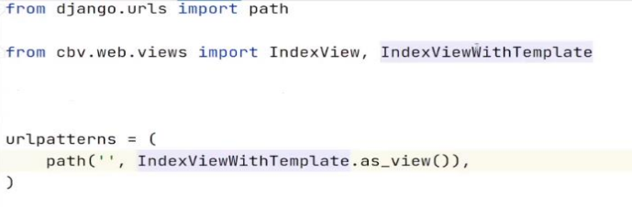

**RedirectView** - performs redirects to a specified URL  
- inherits from the base View class and returns an HttpResponsePermanentRedirect

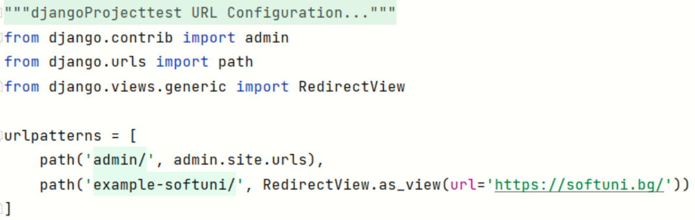

**FromView**- responsible for rendering forms to users  
- Processing the data submitted in the form and performing actions based on the data  
- **CreateView** - displays a form for creating an object  
+ Inherits **SingleObjectTemplateResponseMixing** and **BaseCreateView**)  
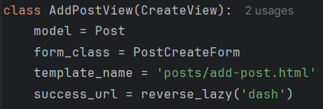  
  
- **UpdateView** - displays a form for editing an existing object  
+ Inherits **SingleObjectTemplateResponseMixin** and **BaseUpdateMixin**  
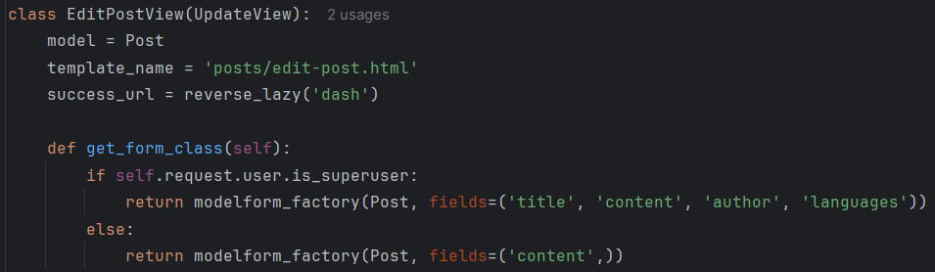  
  
- DeleteView - displays a confirmation page and deletes an existing object  
+ Inherits **SingleObjectTemplateResponseMixin** and **BaseDeleteView**

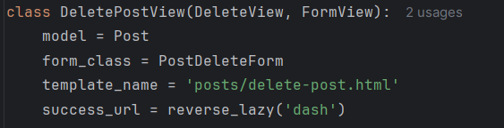

**success_url** - specify the URL to which the user should be redirected after a successful form submission **get_success_url** - method used to determine dynamically the URL to which the user should be redirected after a successful form submission or another successful operation **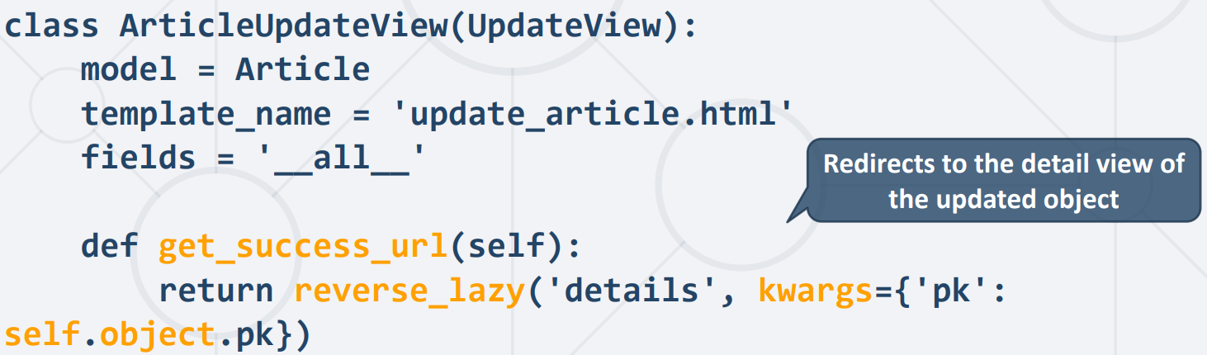  
reverse_lazy -** reverse URL patterns at a lazy, or deferred, time- used to obtain the URL for a given view or URL pattern name  
- useful in situations where the URL configuration is not fully loaded

**DetailView**+ Inherits **SingleObjectTemplateResponseMixin** and **BaseDetailView**

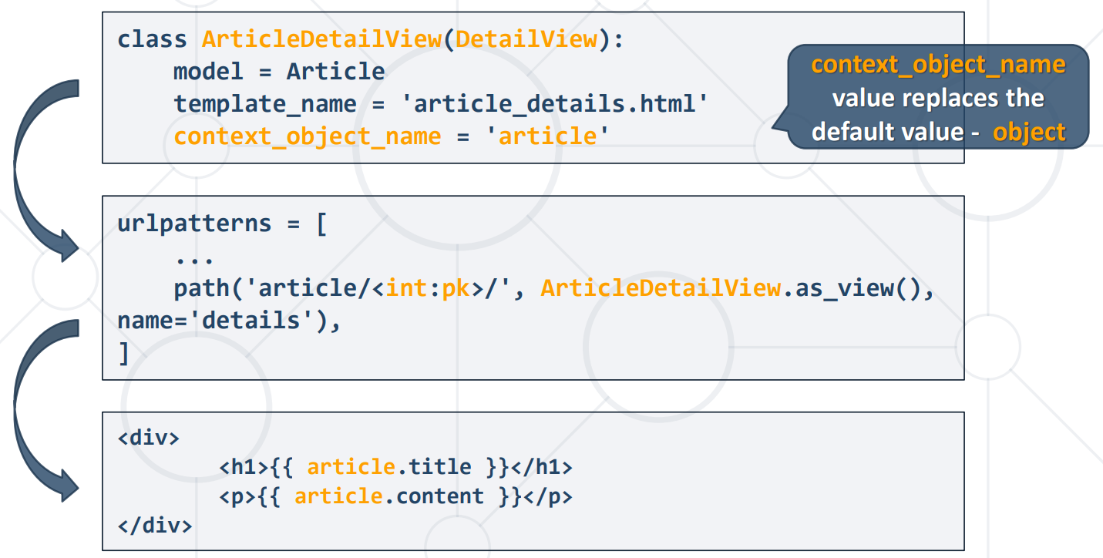  
  
  
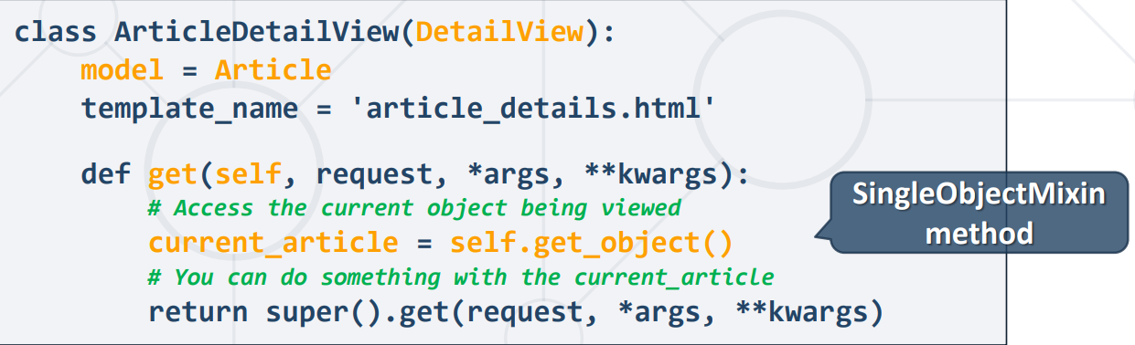

**self.object** – refers to the object that the view is operating upon  
- this object is an instance of the model and is set by the **SingleObjectMixin**  
  
 **get_object** (default behavior provided by the **SingleObjectMixin** class)  
 - fetch and return a single object based on the view configuration and URL parameters

1. gets the queryset
2. tries to get the object by pk and/or slug
3. if pk and slug is None – returns AttributeError
4. else returns the object

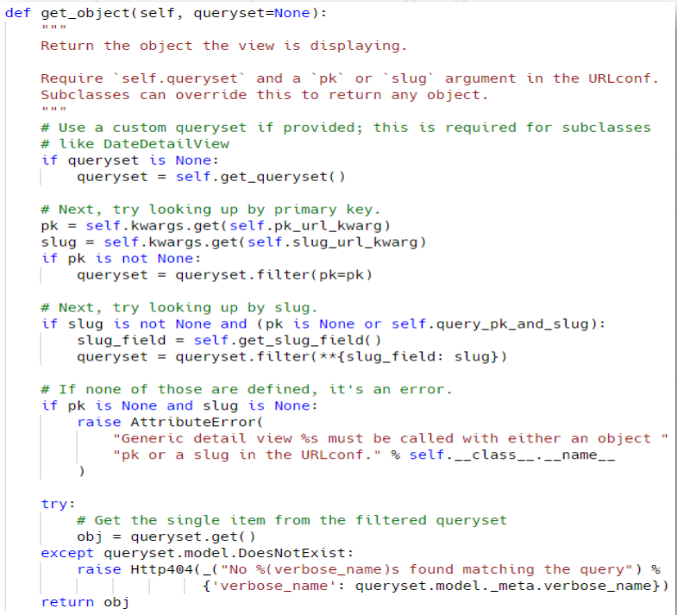

**DetailView Inheritance Chain**  
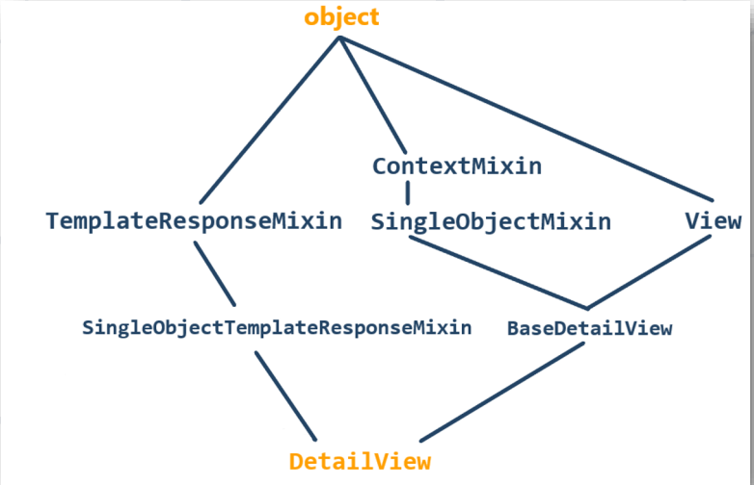

**DetailView** – gets the queryset and the object by matching it with pk or slug  
**SingleObjectTemplateResponseMixin** – provides logic for get_template_names (or allows us not to specify the name of the template but to find it automatically)  
**TemplateResponseMixin** – rendering the template   
 - defining the render_to_response method  
 - defining get_template_names (or which exact template to be returned)  
**BaseDetailView** – predefines the get function (gets the object, attaches it to the context and renders it)  
**SingleObjectMixin** – attach the object to the context  
**ContextMixin** – defines the get_context_data() – passes keyword arguments as template context  
**View –** the foundational master class-based base view in Django  
 - defining the as_view method which then defines the **view** function (attaches the instance of the class to the class attributes using self) and **dispatch** method(determining which method to call)

**ListView**  - specifically designed to display a list of objects  
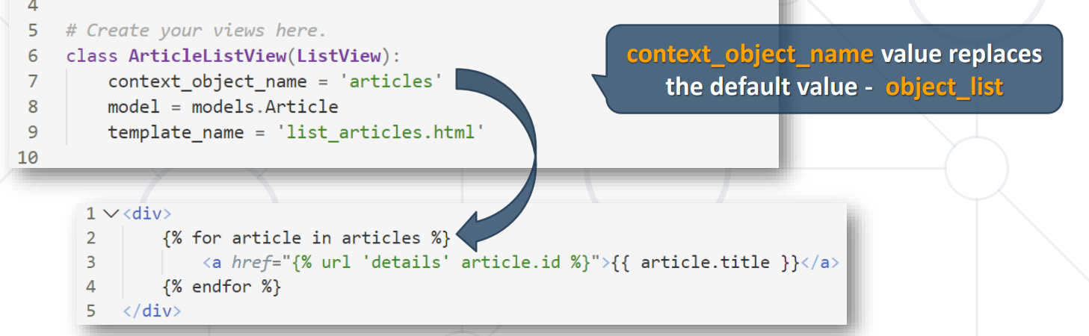  
+ Inherits **MultipleObjectTemplateResponseMixin** and **BaseListView**MultipleObjectTemplateResponseMixin is the same as SingleObjectTemplateResponseMixin with the only difference it returns a list of objects (instead of a single object)  
  
**BaseListView** – defines the **get_queryset()** method that returns the QuerySet that will be used to retrieve the objects the view will display

**Pagination** - the process of dividing a large set of data into smaller, more manageable chunks called "pages"  
 - improve performance and user experience by loading and displaying limited number of items per page  
 (better performance on server level, better performance on the front-end)  
 - supported by Django through **Paginator** and **Page** classes  
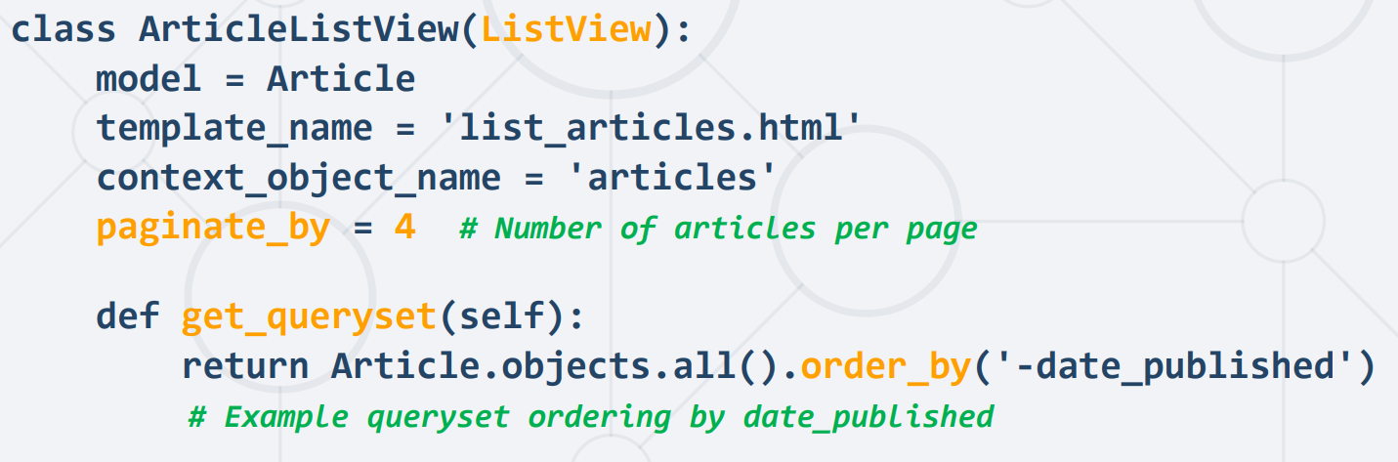  
  
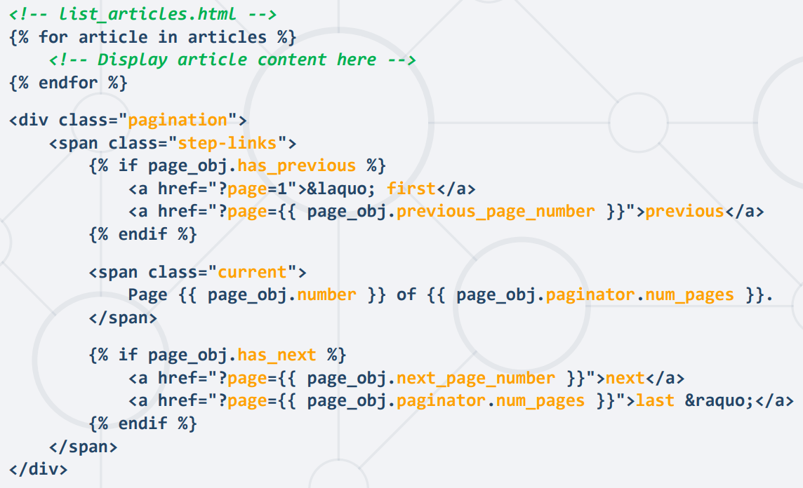

Class based view methods:  
  
**get()** - Handles HTTP GET requests and defines logic for when a GET request is received. **post()** - Handles HTTP POST requests, similar to get(), but for POST actions. **get_queryset()** - Retrieves the queryset to be processed by the view, often used in **ListView** and **DetailView**. Can be set statically or customized dynamically. **get_context_data()** - Adds extra context to the template. Static data can be set in extra_context. **dispatch()** - Determines the HTTP method (GET or POST) for the request and routes it accordingly. Can be used for access control. **get_template_names()**- returns a list of template names for rendering. Can be set statically or determined dynamically.

**get_context_object_name()** - Sets the name of the context variable used in the template, typically for **DetailView** and **ListView**. Can be statically defined. **get_success_url()** - Determines the URL for redirection after a successful action in views like **CreateView** or **DeleteView**. Can be set statically. **render_to_response()** - renders a template with a specific context and returns an HttpResponse. Static context and template settings can be applied.

**Class Based View Decorators**- apply additional functionality to view methods  
- wraps the functionality and adds additional functionality  
- often used for tasks like authentication, permission checks, caching, etc  
  
most times **mixins** are used for **class based views  
decorators** are used for **function based views**